Blacktown City
Art Prize
YOUNG ARTISTS PRIZE
(FOR AGES 3 – 15)

PRIZES

CERTIFICATE OF PARTICIPATION
All entrants will receive a certificate of participation.
INDIVIDUAL AGE PRIZES
Prizes will be presented for the individual entries judged best in each age level.
Age levels eligible for awards will be for children 3 – 15 years of age.
Prizes will include art materials and sketch books.
IMPORTANT DATES FOR ENTRANTS
Delivery date for artworks and entry forms
Friday 13 and Saturday 14 November 2020, 9 am – 5 pm
Exhibition dates
28 November 2020 – 28 January 2021
Open Tuesday – Saturday | 10 am – 5 pm
Awards Presentation
Saturday 5 December 2020, 11 am at The Leo Kelly Blacktown Arts Centre
Collection of artworks
Friday 29 and Saturday 30 January 2021, 9 am – 5 pm
ARTWORK DELIVERY AND
COLLECTION ADDRESS
The Leo Kelly Blacktown Arts Centre
78 Flushcombe Rd Blacktown NSW 2148
(Enter car park via Campbell St)
For enquiries, please call 9839 6558

Proudly sponsored by
Blacktown City Council’s Environmental Services and Kids’ Early Learning

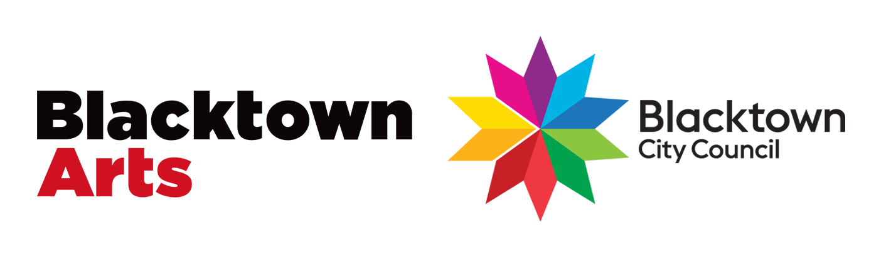

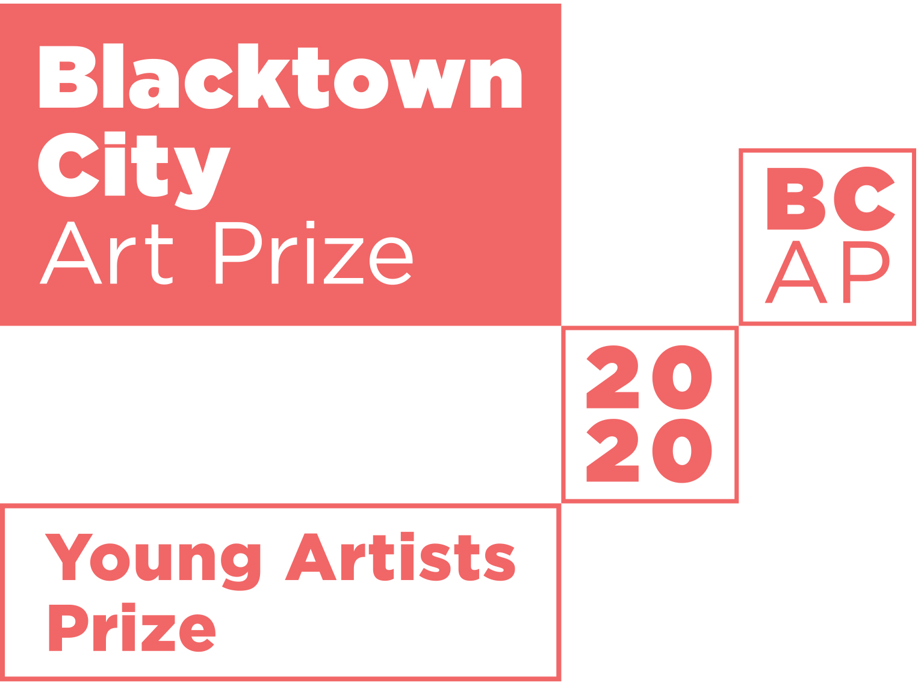

Blacktown City Council is proud to announce the 25th Blacktown City Art Prize.
Young artists are invited to submit entries for exhibition and judging. All entrants
will receive a certificate of participation. The artworks judged best in each age group
will be awarded a prize.

Entry Form
ENTRY FORM AND ARTWORK DUE
9 AM – 5 PM ON FRIDAY 13 NOVEMBER
OR SATURDAY 14 NOVEMBER 2020 AT
THE LEO KELLY BLACKTOWN ARTS CENTRE

THEME
Staying Strong
2020 has been a year of challenges. In NSW, the bushfires burnt 5.4 million hectares of land and destroyed 25% of suitable koala habitat. Since the bushfires, COVID-19 has affected us all, often keeping us indoors. This helps us appreciate the importance of outdoor and natural spaces like local parks and bushland reserves.
As we work to recover from the rough year we’ve had so far, we are asking young artists to make an artwork in response to one of these questions:

1. How can we recover our lost habitats after the destruction of the bushfires?
2. How can we strengthen our community and environment for the future?
The artwork can be a drawing, painting, print, sculpture or ceramic piece. Artworks are exhibited alongside the adult exhibition from Saturday 28 November 2020 to Thursday 28 January 2021.

CONDITIONS OF ENTRY
A parent or carer must read the terms and conditions of this entry form carefully and sign the declaration for children submitting entries.
- Entrants are encouraged to address the above theme in their work, however this is not compulsory.
- There are no fees for entry. Works submitted will not be for sale.
- Blacktown Arts on behalf of Blacktown City Council reserves the right to limit the display to a maximum of 150 works according to quality of work and space availability.
- Entrants must live or attend a school within the Blacktown Local Government Area and be aged 3 – 15 years old on Tuesday 6 October 2020.
- Entries:
  - Each child/young artist is limited to 1 entry
  - Maximum size of works accepted:
Two-dimensional works – A3 size (30cm x 42cm), not including frame
Three-dimensional works – 30cm x 30cm x 30cm
  - For two-dimensional works, entrants are strongly encouraged to frame submitted work.
This will allow professional presentation in the exhibition. Blacktown Arts staff reserve the right to attach hanging devices where necessary.
  - Each entry must bear the title, medium and entrant’s name, address, school, school year, age and phone contact details on the back
  - Each entry must be the original work of the entrant and must have been completed since October 2019.
- Blacktown Arts, Blacktown City Council and/or the media (with Council’s permission) will use images of entrants’ artwork to promote the exhibition and program in signage, websites, social media and catalogues
- The decisions of the Judges and Blacktown Arts on behalf of Council in all conditions of entry, display and judging will be final and no correspondence will be entered into.
- Collection of entries at the conclusion of the exhibition is on Friday 29 or Saturday 30 January 2021 from 10 am – 5 pm. Works that are not collected will be held for 1 week after the arranged pick-up date but will thereafter be disposed of without further notice.

Entry forms can be downloaded from www.blacktownarts.com.au/bcap

ENTRANT’S DETAILS (please print)
First name
Last name Age School Suburb
Please note: Entrants must live or attend school within the Blacktown Local Government Area. A list of eligible suburbs is available here.

PARENT/CARER DETAILS
First name Last name Postal address Suburb State Postcode Telephone Email Who will collect the artwork?
Parent/Carer Teacher

If teacher, please provide name

DETAILS OF ENTRY
Title Medium

DECLARATION
I, the undersigned, have read, understood and agree to the published conditions on this entry form for the 2020 Blacktown City Young Artists Prize. I certify that my child’s entry is their original work, completed since October 2019.
Parent/Guardian Signature Date
(Privacy notice: The information supplied will be used and stored for the purposes of the Art Prize only)

