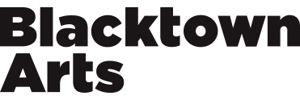

2020 BLACKTOWN ARTS RESIDENCY PROGRAM APPLICATION

PLEASE REFER TO THE 2020 BLACKTOWN ARTS RESIDENCY PROGRAM GUIDELINES BEFORE COMPLETING YOUR APPLICATION.

ARTIST INFORMATION:

Name*

Residential address: Postcode *

Telephone* Email *

What local Government Area do you live in?

What is your art form/s?

RESIDENCY INFORMATION:

Which residency are you applying for?* Will your residency require a space at The Leo Kelly Blacktown Arts Centre? (Please note: Spaces are limited and will be negotiated with Blacktown Arts Staff)
Please tick below
Aboriginal and Torres Strait Islander (You must be Aboriginal and Torres Strait Islander to apply)
Pat Parker Memorial
Performing Arts
Without Borders

Main Street Studios

What is the preferred start and end date for your residency?
(Please note: This needs to be between May 2020 to November 2020)

PROJECT INFORMATION:

Project title*

Brief project description *
(One/paragraph maximum)

Describe your project by telling us what you want to undertake during your residency and why you want to do it?* How will you do it? (500 words maximum)

Who will be involved in your project?

Will you be working with community groups or organisations? How will they be engaged in the delivery of the activity/project and their role/s?

(You will need to provide a support letter from the community group or organisation)

What are the outcomes or your project and how will they be presented?

Will your project include a formal or informal showing for guests such as community groups, peers, potential producers, funding bodies?

ARTIST INFORMATION
Provide a short artist bio for yourself and any other artists or community organisation working with you on the project.* PDF or Word doc only. 5 files maximum. Maximum file size 2MB. CVs must include a contact phone number or email.

BUDGET INFORMATION
Please use supplied template. PDF, Excel or Word doc only, maximum file size 2MB. Applications without a budget will not be considered. Note, successful applicants may not receive the amount requested.

SUPPORTING MATERIAL
Provide evidence of your recent work and any other artist(s) who will be engaged in your project. This can be writing, images, sound, video, or anything else that you consider best represents your practice or project. Submit support material as either URLs or file uploads. For video, please specify a URL from which the work(s) can be viewed, eg Vimeo, YouTube.
- Images
PDF (5 pages maximum) or Jpg file (maximum 4 images) only. Maximum file size 2MB. Total of all files must not exceed 10MB. All artwork files should be named projecttitle-firstname-secondname-artworktitle.jpg, e.g. danceproject-john-smith-dancework1.jpg.
- Website/URL
- List additional websites/URLs (if applicable)

SUBMISSION

Please submit this form at https://blacktownarts.com.au/blacktown-arts-residency-program/

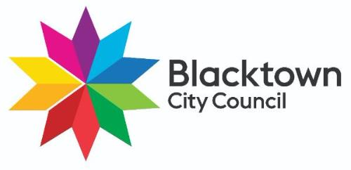
Blacktown Arts Residency Program is an initiative of Blacktown City Council.

