Blacktown Arts | 2018
#ThisIsHowWeMakeArt

Broken Glass

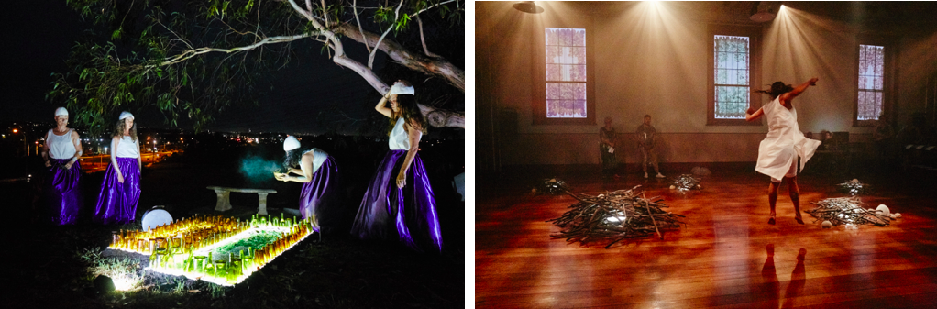
Image: Broken Glass 2017, photographs: Joshua Morris

Artists | Lily Shearer, Liz-Mare Syron, Brenda Gifford, Andrea James, Aroha Groves and Katie Leslie
Project Partners | Moogahlin Performing Arts and Sydney Festival
Project Supporters | Crown Resorts Foundation, Packer Family Foundation and Josheph Medcalf Funeral Services

Vicki Van Hout commission for BlacktownArts.com.au | https://blacktownarts.com.au/broken-glass-vicki-van-hout/

Embedded with Indigenous knowledge practices, Broken Glass acts as a song cycle, an indigenous primer ensuring perpetuity for the next generations to utilise, as well as a work of entertainment – Vicki van Hoot

Lauren Carroll Harris, Audrey Journal on Broken Glass | https://www.audreyjournal.com.au/arts/broken-glass-2/

This for me was the show’s core revelation: that we can restore rites that were denied to those who have paid for colonialism with their lives and whose descendants today still feel the awful burden of genocide. Invasion can’t be undone, but those sacred, healing rituals can still be carried out – Lauren Carroll Harris, Audrey Journal

Recent Acquisitions

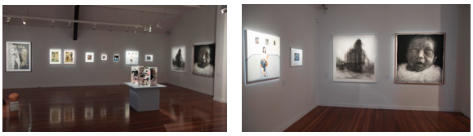
Image: Recent Acquisitions, 2018, photographs: Sharon Hickey

Artists | Brook Andrew, Linda Brescia, Alexandra Byrne, Negin Chahoud, Melissa Chapman, Jane Giblin, Amala Groom, Nerissa Lea, Rebecca Kutnjak, Carmel Mackie, Steven Russell and Kristine Stewart, Marikit Santiago, Rokeya Sultana, Kevin Treloar, Toni Warburton, Unique aka Paul Westgate, Jason Wing and Lisa Woolfe

Daneha

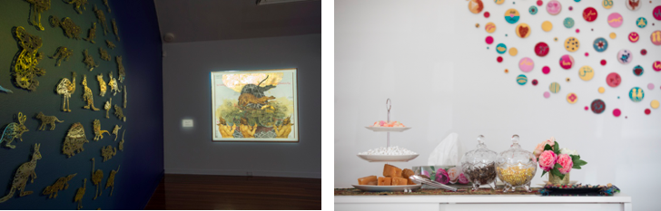
Images. Left: Khadim Ali with Sher Ali, Untitled 3 from the Transitions/Evacuation series. Right: Tea ceremony by Afghan Women on the Move. Photographs: Sharon Hickey
Artists | Khadim Ali (with Sher Ali), Elyas Alvi, Avan Anwar, Zainab Haidariy, Monira Hashemi, Nazanin Marashian, Gerrie Mifsud and Afghan Women on the Move
Project Supporters | Australia Council for the Arts

Abdul Hekmat commission 1 for BlacktownArts.com.au | https://blacktownarts.com.au/how-refugee-artists-transformed-trauma-into-art/

While the figure of the refugee is commonly made synonymous with trauma, loss and victimhood, the Daneha exhibition underscores the courage, resilience and agency of refugees who have transformed their trauma and loss into artworks of beauty to be appreciated. Out of loss and trauma something potent emerges which is enriching and beautiful and may contribute to the artistic culture of Australia – Abdul Hekmat

Abdul Hekmat commission 2 for BlacktownArts.com.au | https://blacktownarts.com.au/afghan-women-find-a-voice-and-space/

Daneha highlights that refugees, and indeed women, cannot be defined only by the narrative of victimhood and loss. In the portraits, you see a community worker, a teacher, a mother, and a young woman who dreams of becoming a footballer and actor. They are not victims of circumstances but a testimony to the resilience of refugees, which is also the journey of humanity – Abdul Hekmat

Sitaraha – The Stars

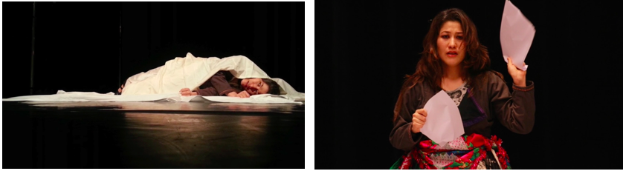
Images: Monirah Hashemi, photography: Dahyu Hashemi

Monirah Hashemi video interview with Blacktown Arts | https://www.facebook.com/watch/?v=297167157759979
Staraha – The Stars is the story of survival, the story of three women… they tell their stories via dances, songs and story-telling to show the resistance and everyday struggle to fight the political, social and religious powers and institutions that want to control their bodies, the minds and their stories – Monirah Hashemi

2018 NAIDOC Family Day

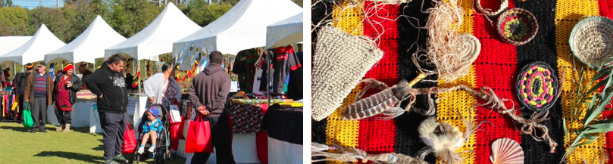
Images: NAIDOC Family Day, photography: Jean Salmi

Artists | Emma Donovan, Glenn Skuthorpe, Marlene Cummins, Shanell Dargan, Sharon Carpenter, Wagana Dancers, Minning Minni Kaiwarrine and Zelden Bell

2018 Creative Arts Fund

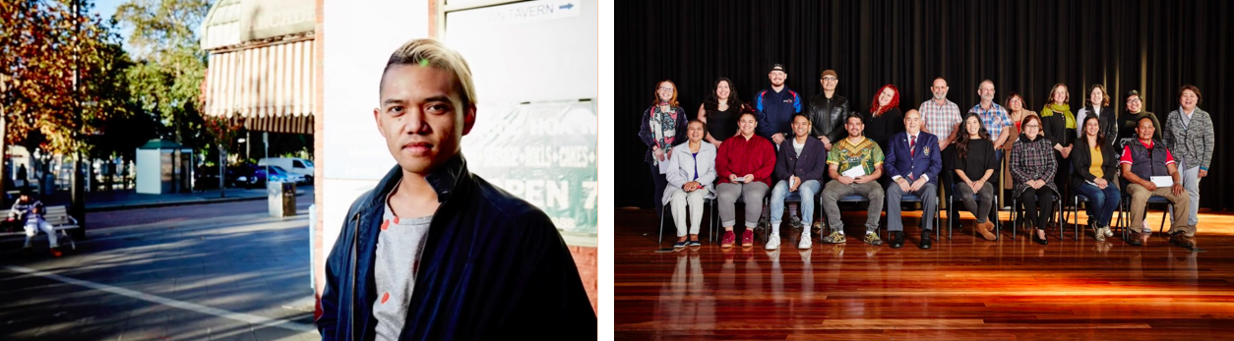
Images: Left: Vonna Patiag, 2018 Creative Arts Fund Recipient, Right: 2018 Creative Arts Fund Recipients, photography: Joshua Morris

Artists | Joycelyn Adan, Miranda Aguilar, Iqbal Barkat, Clarissa Bock, Kristone Capistrano, Elisa Cristallo, Mike Moore and Jeff Lees, Corey James Lonsdale, Helena Mesarovic, Vonne Patiag, Shobana Suresh and Hayley Williams
Organisations | Blacktown Women’s and Health Centre, PCYC Blacktown and Sydney Sonata Singers

2018 Creative Residency Program

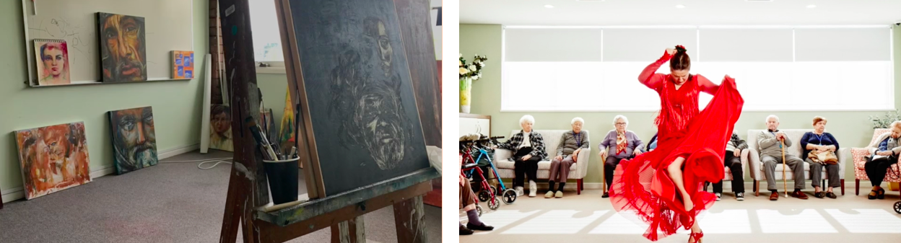
Images: Left: Neda Farrahi’s Main Street Studio, photography: Beth Sorenson, Right: Pepa Molina, Without Borders Resident, photography: Joshua Morris
Artists | Gabriella Florek, Troy Russell, Pepa Molina, Lana Kershaw, Nicole Cadeline, Justine Youssef, Helmy Al Rab, Dennis Sultana, Neda Farah, Sima Alikhani and Michelle Vernot

Stitching the Sea (Oceania Rising)

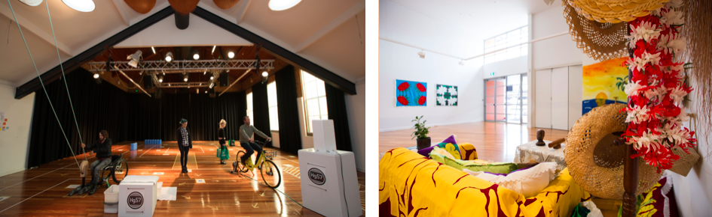
Images: Left: Latai Taumeopeau, Hg57, Right: The Australia Cook Island Community Council installation. Photographs: Sharon Hickey

Artists | Angela Tiatia, Latai Taumoepeau and The Australian Cook Islands Community Council
Project Partners | Australia Museum, Casula Powerhouse Arts Centre, Pacific Islands Mt Druitt Action Network and The Australian Cook Islands Community Council

Gina Fairley for ArtsHub I https://bit.ly/2WzT3qW

At a time when decision makers appear to be ignoring the urgency of the climate change message, artists, museums and communities, more than ever, have a responsibility to ensure that message is truly heard – Gina Fairley

Solid Ground

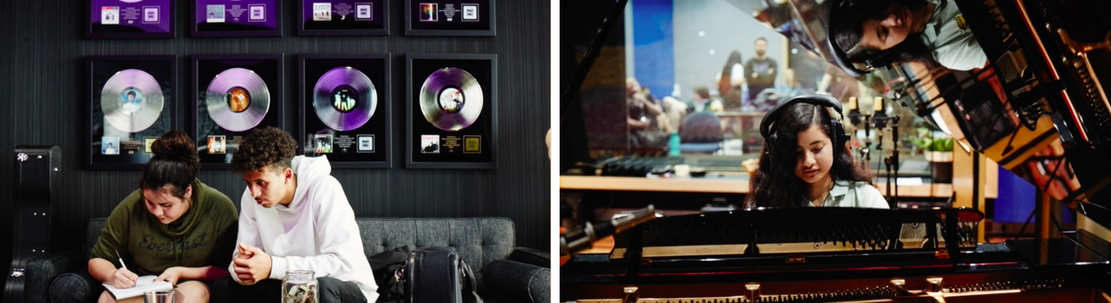
Images: Students recording with Thelma Plum, photography: Joshua Morris

Artists | Darren Compton and Thelma Plum
Project Partner | Carriageworks

2018 Blacktown City Art Prize

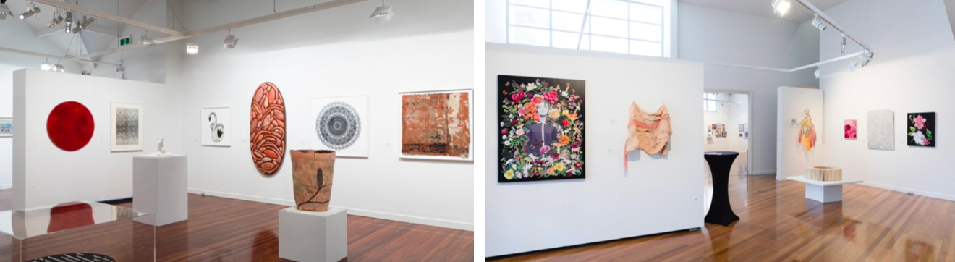
Images: 2018 Blacktown City Art Prize exhibition, photography: Jennifer Leahy.

Artists | 74 artists from across Australia

RIGHT HERE. RIGHT NOW.

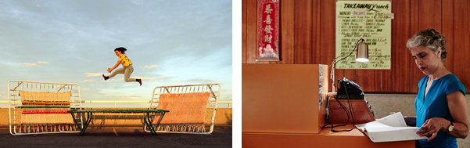
Images: Left: Team Trampoline, photograph by Jonny Barker. Right: The Night Line, photograph by Joshua Morris.

Artists | Uncle Wes Marne, Roslyn Oades, Bob Scott, Meg Wilson, Nicole Barakat, Maharshi Raval, Natasha Lette and Yash Shah, Tom Polo and Rajni Shah.
Project Partners | Urban Theatre Projects
Project Supporters | Australia Council for the Arts, Crown Resorts Foundation, Packer Family Foundation, Bankstown Arts Centre and Loud and Clear

Clarissa Sebag-Montefiore for The Guardian | https://bit.ly/2Pn8a8p

Haunting phone calls, an empty restaurant: how artists recreated western Sydney by night –
Clarissa Sebag-Montefiore

Ngara – Ngurangwa Byallara (Listen, hear, think – The Place Speaks)

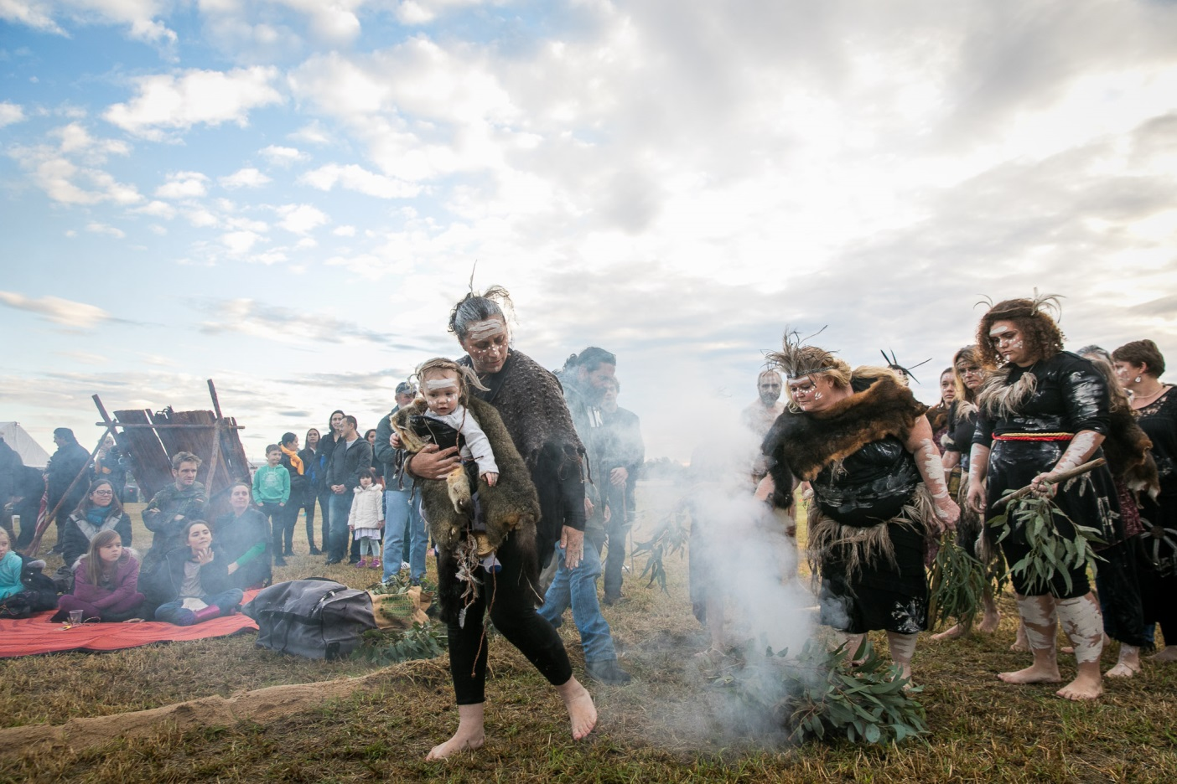
Image: Ngara – Ngurangwa Byallara (Listen, hear, think – The Place Speaks), 2018, Oakhurst NSW, co-commissioned by Blacktown Arts on behalf of Blacktown City Council and C3West on behalf of Museum of Contemporary Art Australia, image courtesy and © the artist, photograph: Anna Kučera

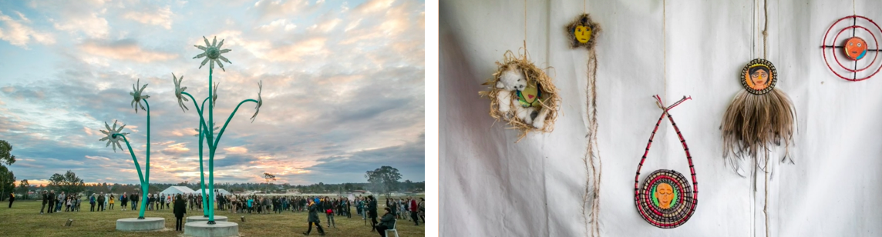
Image: Left: Sharyn Egan, Flannel Flowers. Right: Tony Albert, Gubangala Gumadangyiningi (Let’s honour his/her spirit. Both artworks co-commissioned by Blacktown Arts on behalf of Blacktown City Council and C3West on behalf of Museum of Contemporary Art Australia, image courtesy and © the artist, photography: Anna Kučera.

Artists | Tony Albert, Sharyn Egan and Moogahlin Performing Arts
Project Partners | Museum of Contemporary Art, C3 West and community elders, leaders and members
Project Supporters | Urban Growth NSW, Crown Resorts Foundation, Packer Family Foundation, SPACE, Australia Council for the Arts, Australian Government Visual Arts and Craft Strategy NSW

Jackie Dent commission for BlacktownArts.com.au | https://blacktownarts.com.au/bni-jackie-dent/

Out on the corroboree circle, dramatically lit by red and yellow light, the air filled with the sound of techno beats fused with didgeridoo, the kids are dancing – Jackie Dent

