Blacktown City
Art Prize
YOUNG ARTISTS PRIZE
(FOR AGES 5 – 15)

PRIZES

CERTIFICATE OF PARTICIPATION
All entrants will receive a certificate of participation.
INDIVIDUAL AGE PRIZES
Awards will be presented for the individual entries judged best in each age level.
Age levels eligible for awards will be for children 5 – 15 years of age.
Prizes will include art materials and sketch books.
IMPORTANT DATES FOR ENTRANTS
Delivery date for artworks and entry forms
10 am – 5 pm Friday 9 November 2018 and Saturday 10 November 2018
Exhibition dates
1 December 2018 – 25 January 2019
Open Tuesday – Saturday | 10 am – 5 pm
Awards Presentation
11 am Saturday 8 December 2018 at The Leo Kelly Blacktown Arts Centre
Collection of entries
10 am – 5 pm Friday 1 February 2019 and Saturday 2 February 2019
ARTWORK DELIVERY AND
COLLECTION ADDRESS
The Leo Kelly Blacktown Arts Centre
78 Flushcombe Rd Blacktown NSW 2148
(Enter car park via Campbell St)
For enquiries, please call 9839 6558

Proudly sponsored by
Sustainable Living Blacktown, an initiative of Blacktown City Council

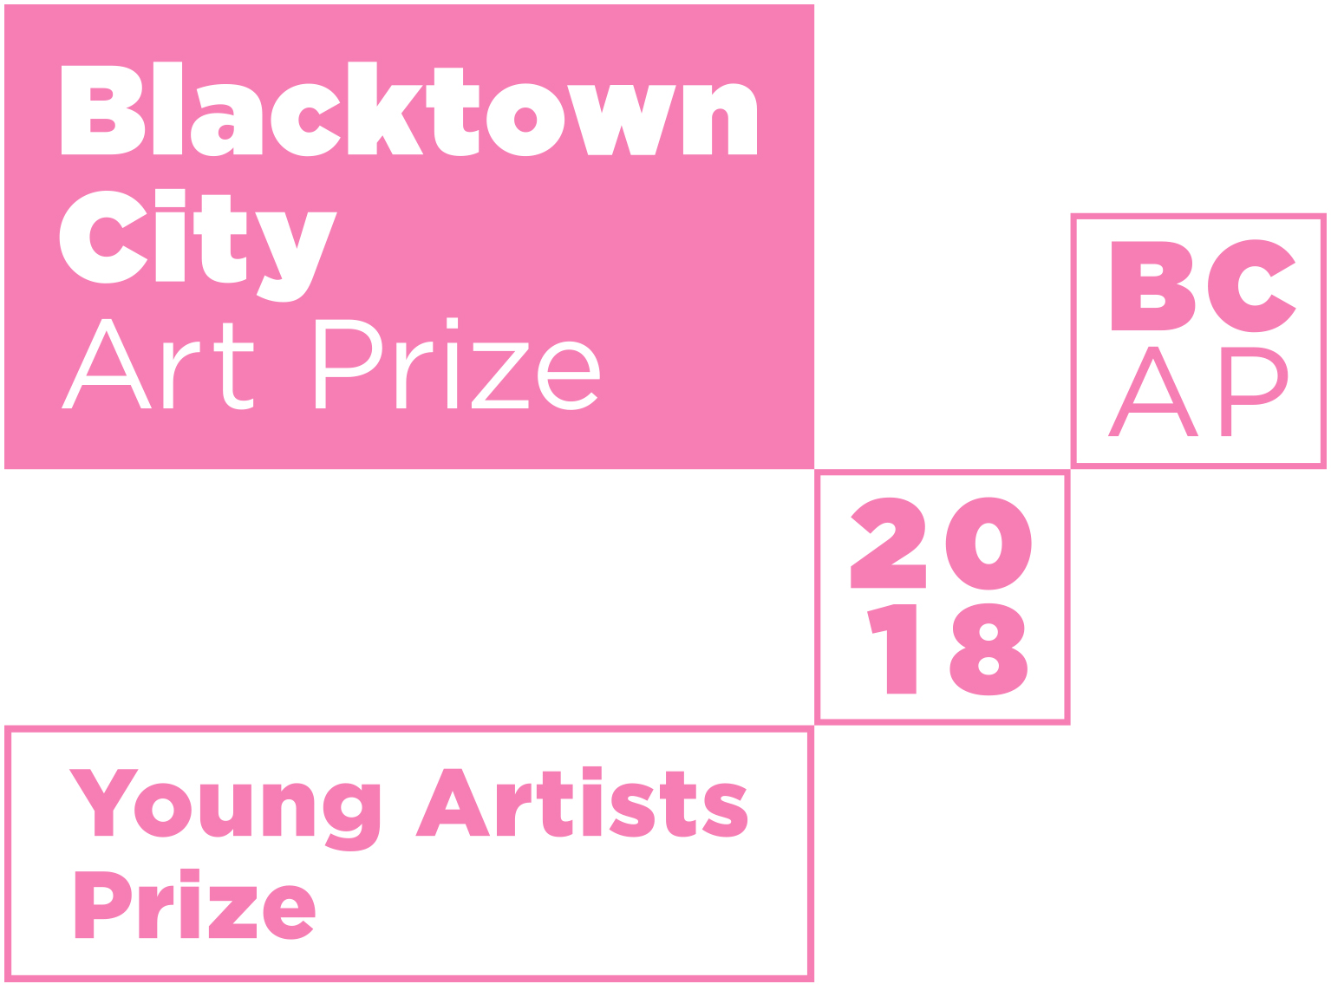

Blacktown City Council is proud to announce the 23nd Blacktown City Art Prize.
Young artists are invited to submit entries for exhibition and judging. All entrants
will receive a certificate of participation. The artworks judged best in each age group
will be awarded a prize.

Entry Form
ENTRY FORM AND ARTWORK DUE
10 AM – 5 PM ON FRIDAY 9 NOVEMBER
OR SATURDAY 10 NOVEMBER 2018 AT
THE LEO KELLY BLACKTOWN ARTS CENTRE

ENTRANT’S DETAILS (please print)
First name
Last name Age School Suburb
Please note: Entrants must live or attend schools within the Blacktown City

PARENT/GUARDIAN DETAILS
First name Last name Postal address Suburb State Postcode Telephone Email Who will collect the artwork?
Parent/Guardian Teacher

If teacher, please provide name

DETAILS OF ENTRY
Title Medium

DECLARATION
I, the undersigned, have read, understood and agree to the published conditions on this entry form for the 2018 Blacktown City Art Prize Young Artists Prize. I certify that my child’s entry is their original work, completed since October 2017.
Parent/Guardian Signature Date
(Privacy notice: The information supplied will be utilised and stored for the purposes of the Art Prize only)

THEME
Bye Bye Plastic
More and more plastic is entering our ocean every day. What can we do to say ‘bye bye’ to plastic and save our marine life?

Use your imagination to create a drawing, painting, print, sculpture or ceramic piece that explores how we can solve the problem of plastics in our ocean.

Artworks are exhibited alongside the adult exhibition from Saturday 1 December 2018 to
Friday 25 January 2019.

CONDITIONS OF ENTRY
A parent or guardian must read the terms and conditions of this entry form carefully and sign the declaration for children submitting entries.
- Entrants are encouraged to address the above theme in their work, however this is not compulsory.
- There are no fees for entry. Works submitted will not be for sale.
- Blacktown Arts on behalf of Blacktown City Council reserves the right to limit the display to a maximum of 150 works according to quality of work and space availability.
- Entrants must live or attend a school within Blacktown City and be aged 5 – 15 years old on Tuesday 9 October 2018.
- Entries:
  - Each child/young artist is limited to one (1) entry
  - Maximum size of works accepted:
Two dimensional works – A3 size (30cm x 42cm), not including frame
Three dimensional works – 30cm x 30cm x 30cm
  - For two dimensional works, entrants are strongly encouraged to frame submitted work.
This will allow professional presentation in the exhibition. Blacktown Arts staff reserve the right to attach hanging devices where necessary.
  - Each entry must bear the title, medium and entrant’s name, address, school, school year, age and phone contact details on the back
  - Each entry must be the original work of the entrant and must have been completed since October 2017.
- Entrants will allow their work to be reproduced by Council and/or the media (with
Council's permission) for art prize promotion, signage, website, catalogue entry and official Council-authored or supported reports only. Council also reserves the right to negotiate with entrants for the use of reproductions of their work for other purposes.
- The decisions of the Judges and Blacktown Arts on behalf of Council in all conditions of entry, display and judging will be final and no correspondence will be entered into.
- Collection of entries at the conclusion of the exhibition is from 10 am – 5 pm
Friday 1 February 2019 and Saturday 2 February 2019. Works that are not collected will be held for one week after the arranged pick-up date but will thereafter be disposed of without further notice.

Entry forms can be downloaded from www.blacktownarts.com.au

