A question fit for a car park: who can call Australia home?
16 January 2017
http://www.bbc.com/news/world-australia-38633102
- Share this with Facebook

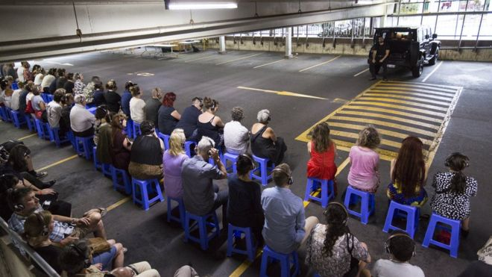Image copyrightJAMIE WILLIAMSImage captionThe show takes place in a car park in western Sydney
A car park in ethnically diverse western Sydney is the scene for a thought-provoking show about Australia's identity, reports Clarissa Sebag-Montefiore.
An Aboriginal elder sets fire to a cluster of native leaves, letting pungent smoke curl into the sweltering summer sky.
This traditional smoking ceremony is not taking place in the bush, however. Rather, he stands next to a steady stream of traffic in Blacktown in western Sydney.
The ceremony marks the start of Home Country, a play that takes place entirely in a multi-level car park, with storytelling juxtaposed against manmade concrete.
According to the 2011 Australian census, 32% of people in greater Blacktown are from countries where English is not their first language. Set in an urban centre with more than 180 different nationalities, the performance asks: who can call Australia home?
"It's a conversation that we think we should be having as a country. And we're really well placed in western Sydney to have that conversation," says director Rosie Dennis of the Sydney Festival world premiere, a joint Urban Theatre Project (UTP) and Blacktown Arts Centre production.

Shunning an elite setting
Located around 35km (28 miles) from Sydney's central business district, Blacktown has more than double the New South Wales state average for murders and triple the number of robberies.
Yet Home Country wants to reach out to the local population by slashing prices for residents, who pay just A$20 (£12; $15) instead of the usual A$59 ticket price. It also seeks to take theatre out of elite buildings into everyday spaces - in this case, the car park.
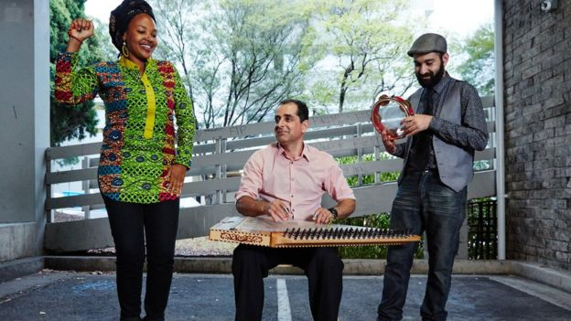Image copyrightJOSHUA MORRISImage captionMusicians Kween G, Mohammed Lelo and James Tawadros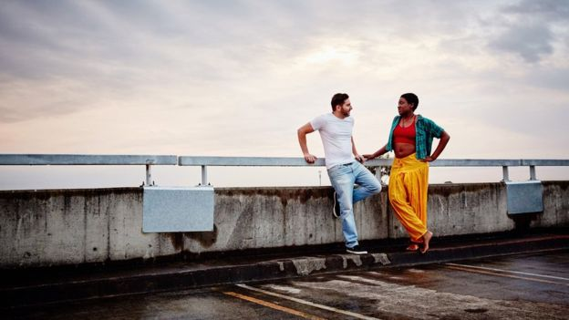Image copyrightHOME COUNTRYImage captionActors Danny Elacci and Nancy Dennis in the show, which happens as the sun sets
"We're looking at multiple perspectives and waves of migration, as well as traditional custodians of the land," says Dennis. "Each work is stand-alone. It's not a single vision, it's a multiple vision that adds to the layer of complexity of the conversation."
Those visions - performed by actors ranging from Aboriginal to African - include two neighbours making small talk on a balcony that ends in a heated discussion of race, and a second-generation Greek man who questions what home might be like without his sick mother.
With the audience guided through different spaces, it aims to provide a more nuanced portrait of both Blacktown itself and the different immigrants who make up Australia.
"If you're not first nations people, you've come here from somewhere else. We're all visitors," points out Ugandan-Australian hip-hop artist Kween G, who acts as MC for Home Country, and moved to Australia as a child seeking asylum with her family.

Just add food
Central is a communal feast included in the ticket. On a hot Friday night, as the sun went down over the Blue Mountains, Ethiopian food was dished out to the sounds of the kanun, a string instrument common in the Middle East, West Africa and Central Asia.
Food is intimately connected to identity and a route into another culture. It's also a conversation starter, says Julieanne Campbell, general manager of UTP: "When you have a shared meal, conversation and connection with people is part of the eating experience."
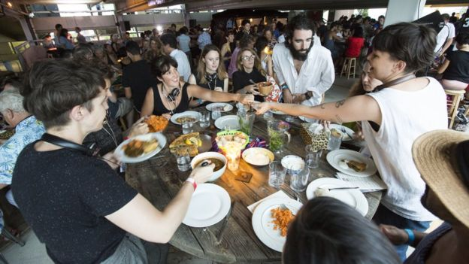Image copyrightJAMIE WILLIAMSImage captionThe audience enjoys an Ethiopian banquet after the show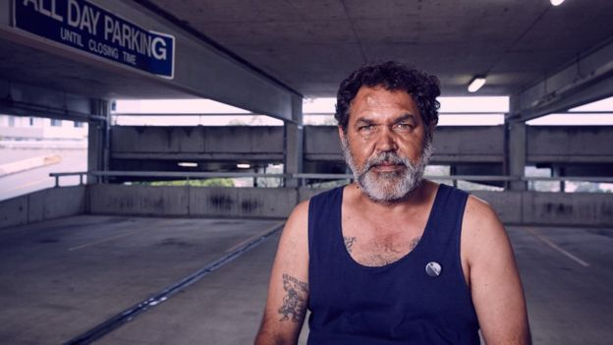Image copyrightJOSHUA MORRISImage captionBilly McPherson as Uncle Cheeky
Nutritionist and audience member Linda Mitar, 39, agrees. Tearing into injera, an East African flatbread, she looks around the feast for 200 people, where guests range from small children to those in their sixties.
"I've spoken to every other person at the table which I normally wouldn't do - it's communal and goes with the theme of being welcomed," says Mitar, who was attracted to Home Country's juxtaposition of "ancient wisdom and sacred ritual in the centre of a busy city".
The event has made her rethink her views on Blacktown, too: "It did have the worst reputation. But given installations like this, it's made me realise how I've under-utilised and haven't appreciated what it can offer."
For local Robert Harcourt, 50, also attending, Blacktown is often "a place people have forgotten about". But he says that's changing because "there's growing pride".
"The past has been designed around the needs of cars," he adds. "To see for one night the cars cleaned out of here and thus space handed over to the public as a place of theatre, of music, of food, of community, that's the strongest thing for me."

'Relevant to people's lives'
For creators, it was crucial to turn spectators into participants and knock down the so-called fourth wall in theatre.
The setting is "outdoors, its connected to a local area, it's in a high point in the city, so you get a vista," says Campbell. "It's a sense of the everyday as well. When you're doing a work that's set in western Sydney, a car park is somewhat relevant to people's lives."
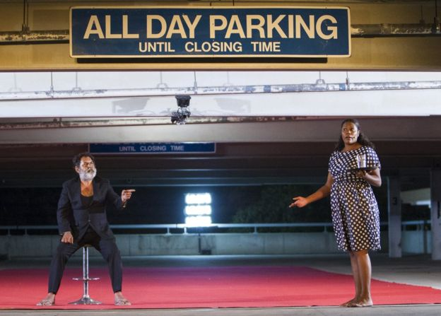
Image copyrightJAMIE WILLIAMSImage captionHome Country is showing as part of the Sydney Festival
Most important, Home Country acts as a source of inspiration. Aboriginal actor Billy McPhersan, who plays Uncle Cheeky, a chirpy, if emotionally lost, elder, believes that the play shows what's possible.
"Nothing like this happens out here," he says. "But I reckon [Blacktown] is going to be on fire."

HOME COUNTRY

https://www.timeout.com/sydney/theatre/home-country

TIME OUT SAYS
3 OUT OF 5 STARS

DETAILS
In this immersive, interactive theatrical journey, Blacktown locals take you on a tour of their suburb via food, music and storytelling
Consisting of three short plays (each staged in parts), with a couple of musical interludes and a meal thrown in for good measure, Urban Theatre Projects’ Home Country is at once place- and site-specific.
The place in question is Blacktown, one of the city’s most multicultural suburbs. The site is a multi-level car park a short walk from the train station, which the audience ascends over the course of the evening.
The car park is in some ways the star of the show. The breeze coming in through the gum trees, the cawing of crows and the hum of early evening traffic, the gradual fading of the light: it’s a wonderfully singular space for a piece of theatre, with the suburb constantly bleeding in at the edges. (The owner of a nearby apartment came out onto her balcony at one point during the proceedings, wondering what all the hubbub was about. She went back inside and shut her curtains.)
The space plays several roles here: it's a home, a nightclub, a pokies lounge, a more abstract, dream-like space, and, of course, an actual car park. Ironically, it is in this last role that its limitations become most apparent – or at least the limitations of the story it’s being used to tell. This is the story of a Greek-Australian man (played by Jonathon Nicholas) whose soliloquy about his dying mother is delivered to the audience through headphones. This piece is only intermittently interesting (and perhaps too reminiscent of Christos Tsiolkas’s Dead Europe) but where it suffers most is in its illustration. You can only watch a man roll and smoke cigarettes in a twilit car park for so long before you begin to zone out, no matter what you’re listening to.
The second part of his story – performed immediately after dinner and again delivered through headphones – is arguably even more static, with the exception of a semi-dance piece performed at the far end of the space, well away from most of the audience. It's the only time when the space feels ill-used. The multimedia approach is distancing in another way.
The other pieces prove more intimate and successful, in part because they’re two-handers in which the chemistry between the performers is both charming and tangible, and because the writing is stronger. The first details the antagonism-turned-flirtation between a Sierra Leonean-Australian (Nancy Denis) and the Lebanese-Australian IT guy (Danny Elacci) who works in her office. (They clash when he suggests that he identifies with her “struggle”.)
The third and most dominant storyline details the guilt felt by an Aboriginal man (Billy McPherson, by turns raffish and tortured) over an act of negligence for which he cannot forgive himself.
Both stories are shot through with sly humour and genuine pathos, and though the racial commentary that infuses them is perhaps less subtle than it could be, both expand and interrogate the idea of “home” in interesting ways. They seem of a piece, mutually revealing, contrasting and comparing the experiences of Indigenous Australians on the one hand and that of recent arrivals on the other. In both cases, these run the gamut from invisibility to demonisation – with scarcely a middle ground of simple acceptance between them. (Though the Greek-Australian piece also deals with the idea of home, it doesn’t feel like it’s in conversation with these other pieces to the same degree.)
To this extent, the show is a way of telling non-white stories in a sphere where they’reunderrepresented, and to an audience whom, one suspects, very rarely ventures west. This is both worthwhile and necessary. But it arguably has the unintended effect of emphasising the centrality of the white gaze to non-white experience, even as it criticises that centrality. (This critique is made most explicit in the story of the young couple, who compare her apparent invisibility as a black woman to his knee-jerk vilification as what the tabloids would call “a young man of Middle Eastern appearance”.)
The result isn't exactly placebo theatre – that middlebrow stuff trotted out by the majors to challenge subscribers’ ideas of themselves in a safe and ultimately consoling way – but it comes close: any sense of self-rebuke white viewers might feel during the proceedings can too easily be weighed against the noble frisson of having attended a show about our multi-cultural reality in the first place.
The result is a kind of impasse. Consider one of the more tellingly awkward moments I’ve experienced at the theatre for a while: watching the Ugandan-Australian hip hop artist Kween G rap to the Middle Eastern melodies of Mohammed Lelo's qanun while a majority-white audience watched on, refusing, for the most part, to tap its feet, let alone to get up and dance. Like the meal that divides the show’s two halves – a combination of Greek, African and Middle Eastern dishes – this moment feels like an invitation to share, to engage, to break down, not only the fourth wall, but other barriers, too: it's a hand extended but not quite taken, with uncertainty or a misplaced sense of theatrical etiquette somehow getting in the way. Needless to say, this isn't really the fault of the show.
But one image lingers: a fugitive vision telescoping and distilling the history of dispossession, and of race and class relations, into one ideal moment that anchors the uneven whole. It comes at the very beginning of the show, after the welcome to country and its attendant smoking ceremony. Shakira Clanton (herself the child of Aboriginal and African-American parents) enters singing a song in language before stopping to gaze from the concrete walls of the car park over the gum trees to the horizon. The built and the natural, the material and the spiritual, the legacy of the settler and the endurance of the survivor. These coexist, however briefly, in a living palimpsest that is very Blacktown, and undeniably Australian. It’s as sad and strangely hopeful an image of home as one is likely to find.
BY: MATTHEW CLAYFIELD
POSTED: SUNDAY JANUARY 15 2017

Mentoring teens: Charles Lomu's barbershop the focus of Harold David exhibition

By Henry Zwartz
https://www.smh.com.au/national/nsw/mentoring-teens-charles-lomus-barbershop-the-focus-of-harold-david-exhibition-20170428-gvujt4.html
Updated 29 April 2017 — 9:21am first published 28 April 2017 — 12:12pm
In a small garage in Sydney's western suburb of Blacktown, self-taught barber Charles Lomu is working to keep men out of trouble and off the streets.
As a young person Lomu – now 39 – fell into crime after a promising start in NRL as a reserve for the Roosters.
"I got into break and entering, car theft, assault and robbery then went on to heavy drinking and struggled with alcohol and got myself locked up", Lomu told Fairfax Media. "When I got out I had to have a sit-down and reflect what was going on in my life."
Lomu, who had been cutting his friends' hair since he was 16, realised barbering was an untapped passion.
"I was always cutting hair right from High School but never once thought it was a career … then I worked on it and it became my job and put me on a good path. I thought this is great, I can use this to help educate other young men about responsibility, respect and manhood."

So Lomu set up a garage barbershop to help young people avoid the mistakes he had made growing up.
Lomu's modest garage barbershop is the subject of an upcoming photo exhibition by fashion photographer Harold David, which traces the barber's mentorship of five young men over a 10-week period.
"David's portraits showcase the impact that a good haircut can have, the feeling of confidence the transformation externally and internally. Being well-groomed can be transformative for these young people … it's about dignity," Lomu said.
Documenting the barbershop was an experience David won't forget. "Charles and his boys are larger-than-life characters. I knew I had to take a back seat and do my job as they presented the most profound moments of my career," David said.
For Lomu, mentoring youth is about saving lives.
Add to shortlist
"This project is about instilling a work ethic in these young men and making them realise if they have a dream and they go out and fight for it they can succeed, they don't need to do stupid things to make a name for themselves. They just need to have someone believing in them."
Garage Barbershop will be on show at Blacktown Arts Centre from May 11 -June 3. Visitors can make an appointment for a cut by Lomu and his five mentees each Thursday during the exhibition at a pop-up barbershop at the Centre.

RELATED GALLERY

Blacktown Garage Barbershop
https://www.smh.com.au/national/nsw/blacktown-garage-barbershop-20170427-gvthk1.html

BARBER BRO: HELPING AT-RISK DUDES, ONE HAIRCUT AT A TIME
Video interview https://www.sbs.com.au/news/the-feed/barber-bro-helping-at-risk-dudes-one-haircut-at-a-time
Ex-crim turned youth worker Charles Lomu runs a barbershop from his garage in Western Sydney where he teaches young clients and trainees what it means to be a good man.

Updated 19 April 2017
By Marcus Costello
Presented by Patrick Abboud
Charles Lomu is a suburban barber with a difference.
His clients range from former inmates to young men at risk of falling into crime, to ordinary suburban blokes who find comfort confiding in him.
Charles has a way of connecting with young guys who find themselves caught up in the criminal justice system – because that’s where he used to be. He did a stint behind bars in his early twenties.
When he decided he wanted to turn his life around, Charles logged in to YouTube and taught himself how to do everything from a French crop to a fifties quiff. He then converted his western Sydney home garage in into a barber shop.
"FUNDAMENTALLY, [BARBERING] IS ABOUT SERVICE TO OTHERS. IT'S ABOUT LEARNING A SKILL AND GIVING TO OTHER PEOPLE IN YOUR COMMUNITY. THAT’S WHAT IT MEANS TO BE A REAL MAN."
Western Sydney has one of the highest rates of property and violent crime New South Wales.
“There's a lot of bravado. Guys can be very territorial, and really passionate about protecting their postcode.”
This isn’t something Charles tries to sugar coat – but he’s determined to change his area’s image.
“Before I got into doing this, it was something that crossed my mind, ‘Do I want to promote my service working from home, put my address out there, knowing what it could bring?’
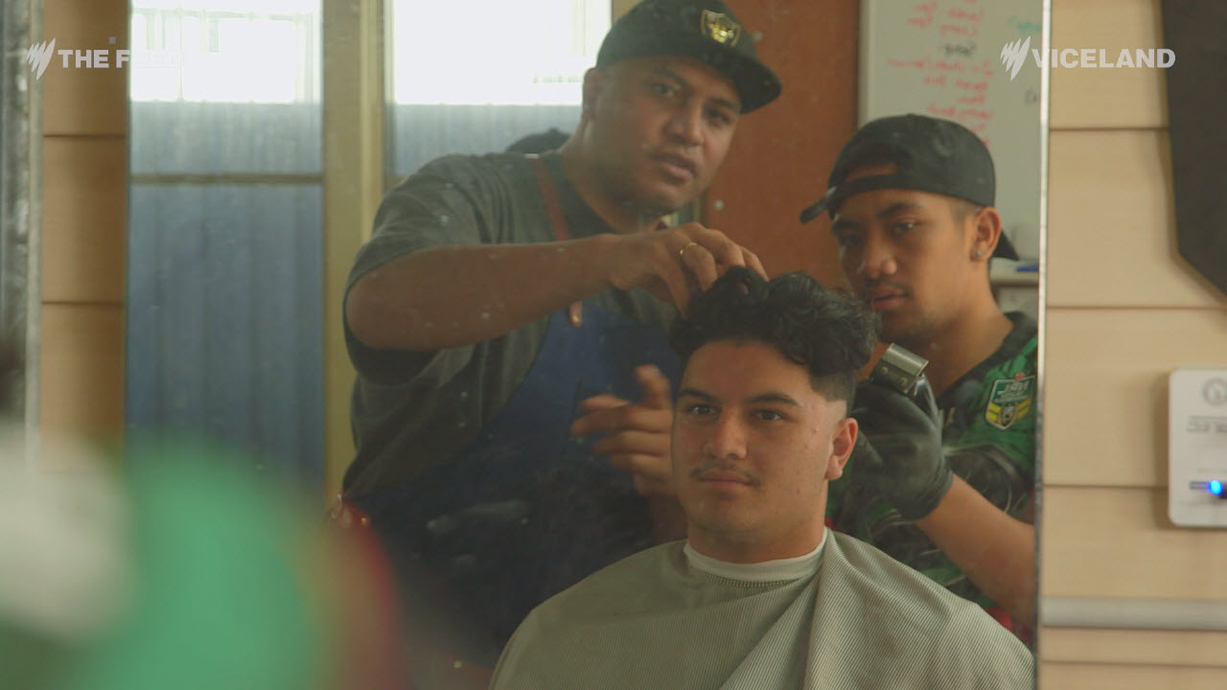
Charles (left) with trainee Kiko (right).
“But then I thought to myself, ‘If I let that stop me, then what am I contributing to?’”
So why does he do it? In his own words:
“We're redefining masculinity. A lot of what I do is about helping men to open up. I think it's hard for a lot of men because it's something society doesn't encourage.
“My generation, we grew up being fathered by men who demonstrated to us that manliness was about being physically strong, being able to control your emotions so no one could see, 'cause if you did it was a sign of weakness.
"Fundamentally, [barbering] is about service to others. It's about learning a skill and giving to other people in your community. That’s what it means to be a real man."
When Charles isn’t serving paying clients, he’s running free workshops for locals like Kiko, Rua and Sione – young trainees keen to follow in his footsteps.
I JUST WANT TO LIVE MY LIFE WITH PURPOSE AND I WANT TO ENCOURAGE YOUNG MEN TO DO THE SAME.
Rua says, “When you cut you always have someone different in a chair, you get to know their story. That's why I like it. You can express your feelings to them and they can express their feelings to you. We talk a lot about what it means to be a man.”
“It does get deep,” says Charles.
“Stories of depression, marriage breakdown; we have some really good talks about religion, deep struggles with alcohol. I can tell by the body language when they come in, something's happened in this guy's life. So I'll purposely probe.
“One guy come in and I was cutting his hair and I seen this big scar on his head. Turned out that he had been shot in the head.
“I have been moved to tears.”
But it’s not all heavy going.
Charles finds out what his trainees are into and works with it.
“The guys that we're working with at the moment, they're a very musical group.”
So between stories of hard luck and redemption, guys break out in song. That’s right, the barbershop quartet lives on.
It really is a whole different world behind roller doors.
#TheFeedSBS airs 7.30pm weeknights on SBS Viceland, stream live, or follow us on Facebook, Twitter or Instagram.
Source: The Feed

JUNE 23 2017 - 3:21PM

Blacktown Council supports local creatives
- Katrina Vo
https://www.hawkesburygazette.com.au/story/4749683/encouraging-innovation/
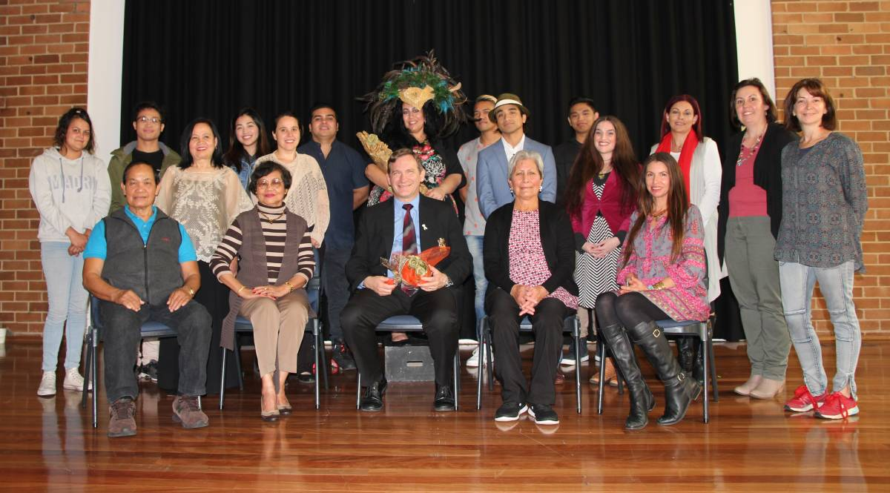SUPPORTING CREATIVES: “I’m proud to be the mayor of a city which has a long and distinguished history of investing in arts and culture,” Blacktown mayor Stephen Bali said.
Encouraging innovation and building strong creative foundations is exactly what Blacktown Council has done.
This month, the council helped 20 local artists and community organisations by awarding them with grants of up to $3000.
“The Creative Arts Fund is an initiative by Blacktown Council, where $40,000 worth of grants are awarded annually to local individuals and organisations to encourage artistic endeavours in Blacktown,” mayor Stephen Bali said.
The talents being supported include singing, web narratives, film making, weaving, ball gown design, the creation of artistic books and video performance pieces.
“We recognise that creativity plays an essential role in building a united, dynamic and sustainable community, and the creation of opportunities for local artists is one of the main priorities of Council’s Cultural Plan,” Councillor Bali said.
The recipients of this year’s Creative Arts Fund grants will use the money to create new artwork, make original music and develop their creative skills.
Recipients include Vonne Patiag of Minchinbury, Daisy Montalvo of Hebersham, Sydney Sonata Singers of Marayong, Baabayn Aboriginal Corporation and PIMDAN (Pacific Island Mount Druitt Action Network) of Blackett, Rosalind Stanley, George Tillianakis and Melissa Chaney of Blacktown, Kealoana Stevenson of Mount Druitt, Angela Paikea-Crombie of Doonside and Michelle Vernot from Toongabbie.
Ms Stanley, who received highly commended awards in last year’s Blacktown City Art Prize, will develop a series of large-scale mixed media works on canvas and paper. In her work, she will examine the diverse culture of Blacktown, and human interconnectedness.
Jenny Bisset, Blacktown Council’s manager of Arts and Cultural Development said the Creative Arts Fund provides local artists with a unique opportunity for professional development.
“It gives developing artists the opportunity to explore creative connections with communities and experiment with new art forms,” she said.
“This is how we like to make art in Blacktown: we build connections, encourage innovation and nurture local talent.”

1 OCT 2017 - 12:30PM

'Balik Bayan' features contemporary Filipino Australian art
- 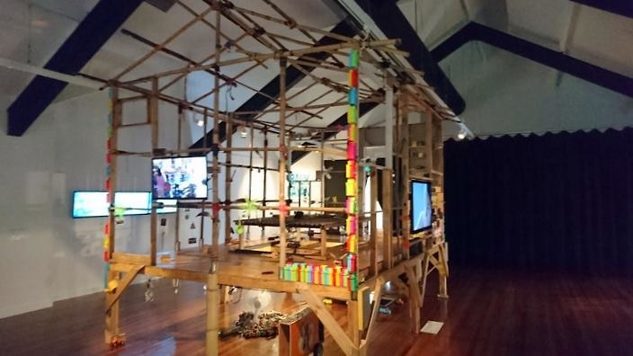
Bayanihan Hopping Spirit house (SBS Filipino/R Manila)
- 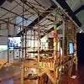
Hide Grid
IMAGE
SBS

Part of the Bayanihan Philippine Art Project, one of the most significant explorations of Filipino art ever presented in Australia, 'Balik Bayan' presents contemporary Filipino Australian art
By
Annalyn Violata
PHOTOGRAPHS AND VIDEO INTERVIEWS: https://www.sbs.com.au/yourlanguage/filipino/en/article/2017/09/13/balik-bayan-features-contemporary-filipino-australian-art
13 SEP 2017 - 7:30 PM UPDATED 1 OCT 2017 - 12:30 PM
Literally translated from the Tagalog language, balik means return and bayan means country, Balik Bayan asks a central question: What does a ‘return to country’ mean for one of the world’s largest diaspora?
Exhibiting artists in Balik Bayan include; Anino Shadowplay Collective, Caroline Garcia, Leeroy New, Robert Nery, Melanie Palomares, Marnie Palomares, Ala Paredes, Bhenji Ra, Melissa Ramos, Alwin Reamillo, Marikit Santiago, Justin Shoulder (UNSW Art & Design), Sinta, Sipat Lawin, and Sydney Sonata Singers.
The Bayanihan Philippine Art Project concludes at Blacktown Arts Centre on 2 November 2017, timed during All Souls Day, a significant date in the Filipino cultural calendar.

JUNE 28 2017 - 1:36PM

It's Our Thing: More on Australian Hip-Hop (Part II)
- Katrina Vo
https://www.hawkesburygazette.com.au/story/4758986/photo-gallery-focus-on-hip-hop-history/
PAINTING THE TOWN: Street artist Matthew Peet has been painting for over 30 years and has created a mural outside of the Blacktown Arts Centre. Picture: Simon Bennett
It’s no secret that western Sydney has a strong influence on the development of Australian hip-hop.
From June until August, Blacktown Arts Centre will celebrate all the things that make hip-hop culture what it is today at the exhibit, It’s Our Thing: More History on Australian Hip-Hop (Part II).
Works are presented both inside and outside the centre by 14 artists, exploring the explosion of hip-hop culture in Blacktown during the 1990s, and its impact on current artistic practices.
Matthew Peet (better known as Mistery) has been one of the founding fathers of the Australian hip-hop scene and has painted a mural outside the centre as part of the exhibition.
The breakdancer, rapper/MC and street artist has been working and forming the culture locally and abroad since the early 1980s.
“In the generation of 80s breakers it was a culture to graffiti if you were a b-boy,” he said. “That’s how I first got into it and it’s the element I chose to follow even though I still break.”
The professional artist has executed numerous commissions for clients such as Sony, Coke, Disney, Mad Magazine and Samsung, just to name a few.
“My works range from graphic design to illustration, cartooning to fine art and mega murals,” the 46-year-old said.
To date he has worked in approximately 20 countries.
“Graffiti and art has become my main state,” he said.
“Keeping hip-hop culture alive in the community showcases what’s going on around town and Blacktown Arts Centre has been a great space in supporting these kinds of initiatives.”
In the 1990s, Blacktown was home to western Sydney’s first artist-run initiative, Street Level, led by graduates from the Western Sydney University and the College of Fine Arts.
Curated by Kon Gouriotis and Paul Howard, It’s Our Thing (Part II) features some of the original graffiti artists and visual artists active during that time.
“The hip-hop movement in Australia, like that in America, was a form of expression by people outside the mainstream of fine arts and music,” Mr Gouriotis said.
“Street Level was significant because the works that emerged embodied the signature and tone of a distinctly Australian hip-hop voice that continues to resonate.”
The exhibition includes performances, paintings, graffiti – both at the centre and throughout the Blacktown CBD – video displays of female hip-hop performers from the 90s to now, and a rare original piece by visual artist Unique, last displayed in 1992.
- It’s Our Thing (Part II) will run until August 12 at Blacktown Arts Centre, 78 Flushcombe Rd, Blacktown. Free.
+10

THE CONVERSATION
https://theconversation.com/how-filipino-artists-are-responding-to-president-duterte-and-the-war-on-drugs-84510

Top of Form
Bottom of Form

How Filipino artists are responding to President Duterte and the ‘War on Drugs’
November 28, 2017 6.09am AEDT

Author
Anna Cristina Pertierra
Senior Lecturer, Cultural and Social Analysis, Western Sydney University
Along one long wall on the side of Manila’s Baclaran church, visual artist Emil Yap has been working for two years on a mural that depicts the cosmology and history of the Philippines.
Yap collaborates with others on the mural, which uses different sculpture and mosaic techniques. Recently, he trained volunteers who were victims of President Rodrigo Duterte’s declared “War on Drugs” - which is estimated to have led to more than 13,000 killings - to work on the mosaics for several months while seeking refuge in the church.
Yap is among a small but growing number of cultural producers whose work addresses the effects of Duterte’s presidency. Several of these artists seek to involve members of communities most affected by the upsurge in killings - which are mostly in low-income urban neighbourhoods.
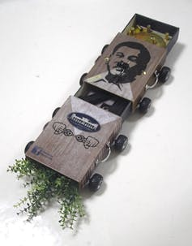
Alwin Reamillo places images of President Duterte on everyday objects. Alwin Reamillo
Not far from Baclaran Church, at the Cultural Center of the Philippines, performance-maker JK Anicoche collaborated with young widows of the drug war to perform Zumba as part of a performance entitled 15 Minutes of Your Time. A response to self-declared drug addicts across Manila being made to participate in mass Zumba sessions as part of their rehabilitation process, the dance-based exercise form now has a somewhat macabre presence in contemporary Philippine life.
Anicoche and Yap are part of an loose extended network of artists who have been working under the banner of the RESBAK collective (Respond and Break the Silence Against the Killings). RESBAK members make zines, hold film screenings, and produce videos for circulation on social media as part of their diverse efforts to protest.
Their launch video in December 2016 played a famous Filipino Christmas song as a backdrop to protesters silently holding cardboard placards that call to mind the homemade signs often left beside slain bodies.
Cultural projects such as these can offer tools for violence-affected communities to work through their trauma. Among the victims most deeply impacted are children. The Philippine Center for Investigative Journalism has published a children’s book, Si Kian,narrating the story of teenager Kian de los Santos, whose fatal shooting by police in August 2017 led to protests.
Journalist Kimberley de la Cruz, who had been covering the nightly killings for some months before meeting Kian’s family at his wake, collaborated with author Weng Cahiles and illustrator Aldy Aguirre to produce Si Kian within a matter of weeks. The illustrated book aims to provide a resource to teachers seeking resources for young students experiencing deaths like that of Kian’s within their neighbourhoods.

Shifting alliances
Like other Filipinos, artists are coming to terms with the tensions emerging between Duterte’s supporters and detractors. Some artists had been among those optimistic for change when President Duterte formed alliances with some leftist groups and promised to shake up elitist politics.
But as curator and academic Lisa Ito-Tapang has noted, over the past year Duterte’s alliances have steadily shifted, including a more prominent alliance with the family of former dictator Ferdinand Marcos, and “a lot of the positionings of artists also reflected those kinds of shifts”.
For example, a 2016 recent exhibition at the University of the Philippines, Dissident Vicinities, featured works by the militant leftist group BAYAN among other activists and artists. The group is known for making effigies of politicians to be burned at rallies.
However, during Duterte’s first State of the Nation address in 2016, BAYAN instead produced six “Portraits of Peace” murals, inviting Duterte to address pressing challenges across the Philippines. But a year later, BAYAN returned to making effigies in protest at the political repression.

The view from the disapora
Beyond the Philippines, political tensions are also reflected in the work of artists in the diaspora. At Western Sydney’s Blacktown Arts Centre - Filipinos are the largest migrant community in Blacktown - glimpses of Duterte could be seen across many works in Balik Bayan, a recent exhibition of Filipino-Australian artists.
Underneath a house built by artist Alwin Reamillo, a toy Japanese cat waved welcome. With Duterte’s face plastered over the cat’s head, the wave looks increasingly like the president’s signature fist-pump. Alwin has been adding Duterte’s head to different items (matchboxes and wooden pieces) for several months, and plans to keep reworking Duterte’s image in upcoming exhibitions. Alwin is openly critical of the consequences of Duterte’s Presidency upon Philippine society.
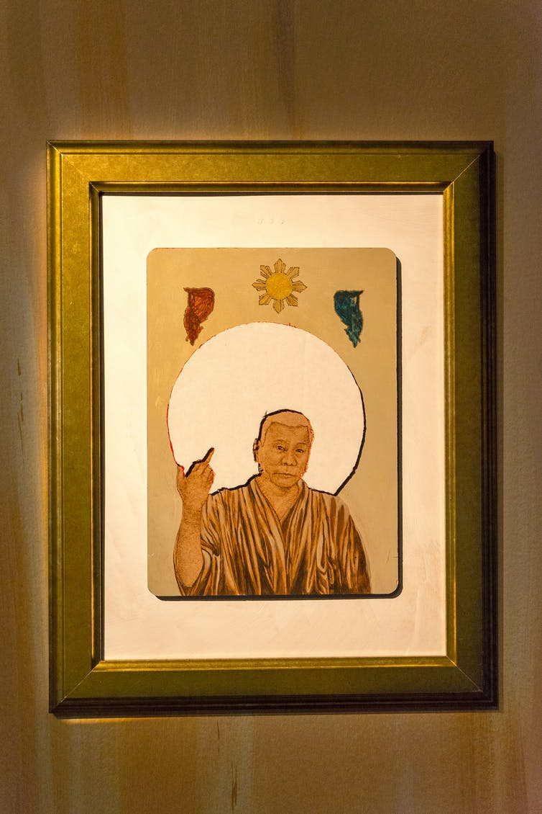
Marikit Santiago’s images present Duterte in ways both religious and profane. Photo by Jade Cadeliña
In the same exhibition, Marikit Santiago presents an image of Duterte at once religious and profane. Although Santiago says she does “not have a strong political voice”, her work was prompted by conflicting opinions on Duterte within her own extended family, where political discussions had not previously been common.
In Sydney this October, the LabAnino collective of Filipino and Australian artists performed a new work, This Here. Land. It reflected political differences held within the collective, where members were variously supportive and critical of Duterte.
In the piece’s culmination, outgoing audience members participated in a recreation of the most famous photographic image (see below) to emerge from coverage of Manila’s late-night killings. Incoming audience members, meanwhile, used their phones to illuminate and document the recreation of the image. All are complicit in the witnessing, debating and disputing of new political realities.
Across the political and geographic differences that mark Filipino communities at home and abroad, artistic initiatives may be creating small spaces in which people can attempt to bridge increasingly tense divides.
These may offer hope not only to those caught up in its violence, but also to other Filipinos seeking ways beyond the political realm to make sense of their circumstances.

SBS FILIPINO

The Distant Memories of Melissa
https://www.sbs.com.au/yourlanguage/filipino/en/audiotrack/distant-memories-melissa-1
When Melissa Ramos' parents went to visit the Philippines, she asked them to bring her old 8mm film video camera to capture their stay. Image: snapshot of Melissa Ramos' "Distant Memories"
By
Jake Atienza
Published on
Wednesday, October 4, 2017 - 13:45
File size
2.67 MB
Duration
5 min 50 sec
This resulted in “Distant Memories”, a three- channel video piece currently showing at the Blacktown Art Centre. Distant Memories, she says,became a way to “re-write” the memories of her parents in the Philippines.
Melissa Ramos’s “Distant Memories” is part of Balik Bayan, a program of contemporary Filipino art at the Blacktown Arts Centre running from 7 September to 4 November 2017.

