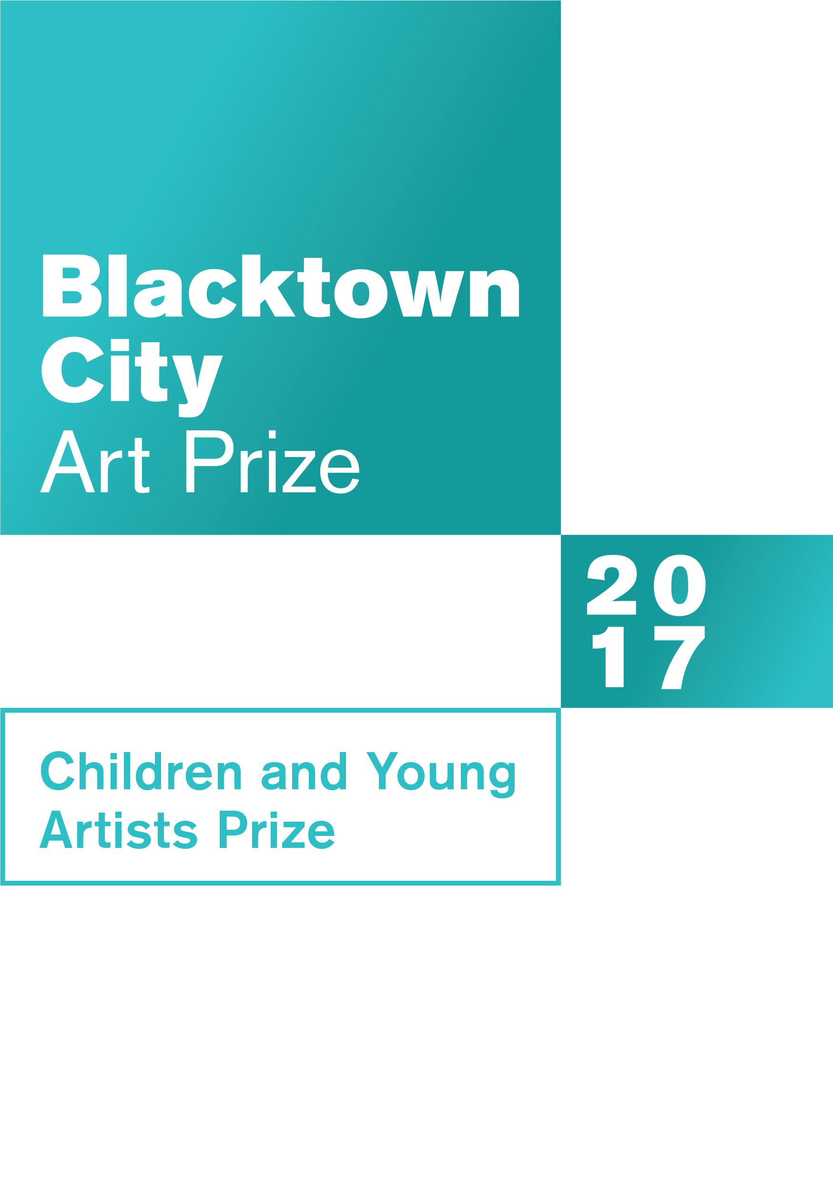

Blacktown City
Art Prize
CHILDREN AND YOUNG ARTISTS PRIZE (FOR AGES 5 – 15 )

PRIZES

CERTIFICATE OF PARTICIPATION
All entrants will receive a certificate of participation
INDIVIDUAL AGE PRIZES
Awards will be presented for the individual entries judged best in each age level. Age levels eligible for awards will be for children 5 – 15 years of age. Prizes will include books, art supplies, board games.
IMPORTANT DATES FOR ENTRANTS
Delivery date for artworks and entry forms
10 am – 5 pm Friday, 10 November 2017 and Saturday, 11 November 2017
Exhibition dates
2 December 2017 – 27 January 2018
Open Tuesday – Saturday | 10 am – 5 pm
Awards Presentation
11 am Saturday, 9 December 2017 at Blacktown Arts Centre
Collection of entries
10 am – 5 pm Friday, 2 February 2018 and Saturday, 3 February 2018
ARTWORK DELIVERY AND COLLECTION ADDRESS
Blacktown Arts Centre
78 Flushcombe Rd Blacktown NSW 2148 (Enter Arts Centre car park via Campbell St) For enquiries please phone 02 9839 6558

Proudly sponsored by
Sustainable Living Blacktown,
an initiative of Blacktown City Council

Blacktown City Council is proud to announce the 22nd Blacktown City
Art Prize. Children and Young Artists are invited to submit entries for exhibition and judging, with certificates and age group prizes on offer.

Entry Form
ENTRY FORM AND ARTWORK DUE 10 AM – 5 PM FRIDAY, 10 NOVEMBER 2017 AND
SATURDAY, 11 NOVEMBER 2017
Blacktown Arts Centre
78 Flushcombe Rd Blacktown 02 9839 6558

ENTRANT’S DETAILS (please print)
First name
Last name Age School Suburb
Please note: Entrants must live or attend schools within the Blacktown local government area (LGA).

PARENT/GUARDIAN DETAILS
First name Last name Postal address Suburb State Postcode Telephone Email Who will collect the artwork?
Parent/Guardian Teacher

If teacher, please provide name

DETAILS OF ENTRY
Title Medium

DECLARATION
I, the undersigned, have read, understood and agree to the published conditions on this entry form for the 2017 Blacktown City Art Prize Children and Young Artists Prize. I certify that my child’s entry is their original work, completed since October 2016.
Parent/Guardian Signature Date
(Privacy notice: The information supplied will be utilised and stored for the purposes of the Art Prize only)

THEME

Building and Landscape
Think of a landscape – it can be real or imagined. Sculpt, paint, draw or build your ideas about
shelter or structures in the landscape.

Here are some questions to think about when you are creating your art work:
What is a built environment?
What kind of shelters and structures do we build, and why?
Can you move the structure? Should it last forever?
Does what we build change the landscape, or can the landscape inspire what we build?
Lots of new suburbs are being built today. How will Blacktown look in the future?

Artworks are exhibited alongside the adult exhibition from Saturday,
2 December 2017 to Saturday, 27 January 2018.

CONDITIONS OF ENTRY
A parent or guardian must read the terms and conditions of this entry form carefully and sign the declaration for children submitting entries.
- Entrants are encouraged to address the above theme in their work, however this is not compulsory.
- There are no fees for entry. Works submitted will not be for sale.
- Blacktown Arts Centre on behalf of Blacktown City Council reserves the right to limit the display to a maximum of 150 works according to quality of work and space availability.
- Entrants must live or attend a school within the Blacktown local government area and be aged 5 – 15 years old on Tuesday, 10 October 2017.
- Entries:
  - Each child/young artist is limited to one (1) entry
  - Maximum size of works accepted:
Two dimensional works – A3 size (30 cm x 42 cm), not including frame Three dimensional works – 30 cm x 30 cm x 30 cm
  - For two dimensional works, entrants are strongly encouraged to frame submitted work
This will allow professional presentation in the exhibition. Blacktown Arts Centre staff reserve the right to attach hanging devices where necessary
  - Each entry must bear the title, medium and entrant’s name, address, school, school year, age and phone contact details on the back
  - Each entry must be the original work of the entrant and must have been completed since October 2016.
- Entrants will allow their work to be reproduced by Council and/or the media (with
Council's permission) for art prize promotion, signage, website, catalogue entry and official Council-authored or supported reports only. Council also reserves the right to negotiate with entrants for the use of reproductions of their work for other purposes.
- The decisions of the Judges and Blacktown Arts Centre on behalf of Council in all conditions of entry, display and judging will be final and no correspondence will be entered into.
- Collection of entries at the conclusion of the exhibition is from 10 am – 5 pm Friday, 2 February 2018 and Saturday, 3 February 2018. Works that are not collected will be held for one week after the arranged pick-up date but will thereafter be disposed of without further notice.

Entry forms can be downloaded from www.blacktownarts.com.au

